**Top 10 Residential Apartments in Karjat**

Karjat is a Pleasant climate consists of evergreen and healthily environmental town in Raigad district which is located in state Maharashtra, India. This region is located approximately at distance 70km away from Mumbai and 100km from Pune. It is one of the best and ideal locations for living and working with multiple choices in improvement of better lifestyle. The location has huge number of population in the regions, as most of the people from Metropolitican cities are nowadays prefer to move towards karjat side region in the search of property, education and Business related work. Because of increasing property value, the people choose to move to karjat due to affordable price range of property within the region. Featured with great facilities include Schools, Colleges, grocery market, Restaurants,Mall.It is also an ideal place for weekend destination which is easy access to various point of attraction such as Lonavala, Khandala and Malshej Ghat and many more in Karjat. As it is located closeness to Mumbai Metropolitan Region’ there will be no issue related to travel transport facilities. You can find various options for travelling with the region as well as outside the region.

When you have dream to live a luxurious life, Karjat becomes one of the prime choices. The availability of quality properties and advanced lifestyle make the place livable for people who desire comfort.However, when you are looking for the Karjat luxury home, there are various factors to keep in mind. The evaluation of a variety of factors can help you to live a comfort life in Karjat.There are many areas where one would definitely love to live in. To search for top most residential properties in Karjat, this is the right place to search for it. Some of the top most 10 residential properties in Karjat are listed below.

1. **Arihant Aloki:-**

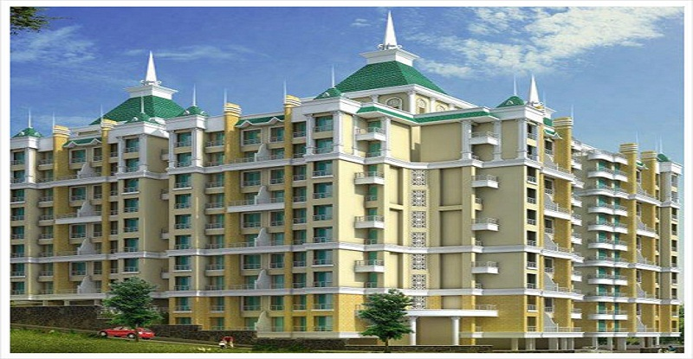

**About Project:-**

Arihant Aloki is newly launched luxurious development project in karjat, developed by Arihant Superstructures ltd. This is one of the beautiful and outstanding luxurious properties with perfect blend of modern lifestyle with high quality class amenities. The project is constructed in pleasant and clam environment in a beautiful and attractive scenery view from apartment location. It is strategically located and provides direct connectivity to all nearby major points in and around this apartment is suitable for all small, large families, professionals, students. This ultimate reflection of the urban chic lifestyle apartment is available ready to move on Dec 2019.

**Project Configuration Details:-**

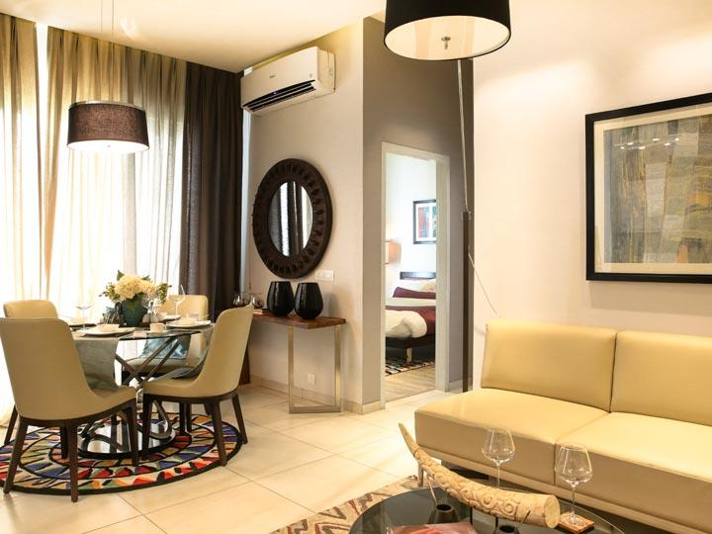

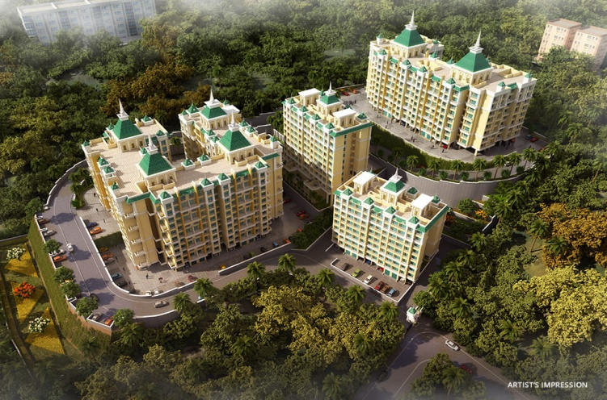Arihant Aloki is one of the extremely impressive architectural Apartments in karjat, consisting of 1BHK and 2BHK apartments in affordable price range, starting from 22L to 29.99L onwards. Each apartment consist of 2*2 vitrified flooring in all rooms, POP on all walls with moulding cornices, luster paint on internal walls, Granite top kitchen platform with s.s sink and service platform with full height glazed tiles above platform, Aluminum powder coated sliding windows, concealed plumbing with premium quantity bathroom fitting and branded sanitary ware, full glazed tiles in bathroom,moulded panel for main door and bedroom doors, dedicated space for wash basin and washing machine, concealed electrical wiring with ample electrical points and modular switches,etc.This master plan of Arihant Aloki comprises of unique design that affirms a world-class lifestyle and prestigious accommodation in apartment. This project is suitable for small and large family, professionals and students who stay in apartment in search of job and studies.

**Highlights:-**

* Family-friendly apartment in affordable price range in a pleasant environment.
* Premium 2BHK and 1BHK standardized apartments with modern amenities.
* Easy accessible to attractive and beautiful weekend places.
* Well-transportation connectivity to all small and major regions from locality.

**Project Amenities:-**

This impressive and urban style designed apartments consist of amenities such as Landscape Garden, Indoor and Outdoor games, Earthquake Resistant, CCTV Cameras, Intercom, Rainwater Harvesting, Lift, Gymnasium, Swimming pool, gated community, Play area,24Hr Backup Electricity, Club House, party Area, Senior Citizen Park, Health facilities, Drainage and sewage treatment, fire alarm, fire fighting system,24Hr water Supply and many more.

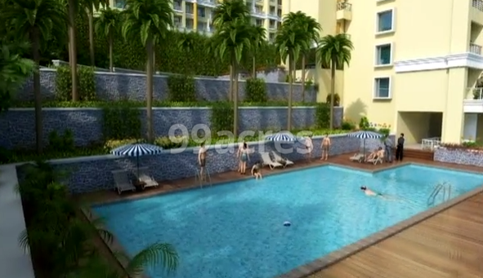

**Transportation facilities:-**

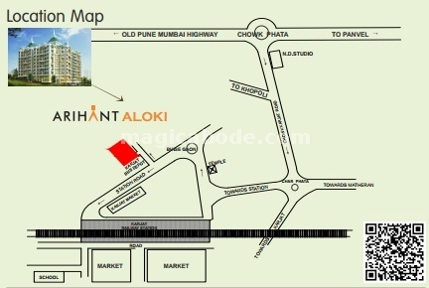Arihant Aloki is located in region of pleasant climate which is well facilitated with transportation connectivity to all major cities and small region. Karjat is a region accessible via NH17, NH4 and NH3 highways. The extensive roadway networks connected to localities like Murbad, Kaiyanpur, Kasar Ghat, Khapoli, Khalapur, Neral, Badlapur, Ambernath, Pen, Panvel, etc.For moving from one region to other people can use their private four wheelers or two wheelers facilities. There is also a mixture of service in the region, comprising of MSRTC buses, 6-seater mindors, 3-seater auto rickshaws and 6-seater vans. The nearby station from Arihant Aloki is karjat station which is just 3mins distance away. This station is a junction where you can find an express train as well as local trains for moving towards Mumbai and Pune. There is also Airline facilities such as Chatrapati Shivaji International Airport and Navi Mumbai International Airport is nearest airport.

**Neighborhoods facilities:-**

Neighborhood facilities like various schools and institutes within the localities that a resident of area has no problems related to their children’s education. Some of the schools such as DAV Public school, St Joseph’s High School, India First Global School, New Horizon Public School, Biotech Research Institute, Dhirubhai Ambani School Lodhivali, etc.For healthcare related issues, residents doesn’t have to move to Mumbai for checkup, there are number of major health institution such as Raigad Hospital and Research Center, Madhavbaug Hospital,etc.There are also various Banks, ATM, Shopping centers and many more for residents without moving to metro Politian city, you can find all within the locality of Karjat.

**About Developer:-**

Arihant Superstructures ltd is a leading real estate company, famous for developing impressive projects across Navi Mumbai. The main focus of the company is to develop standardized homes with high quality materials, designed by experienced professional architectures and always tries to deliver on time. By providing world-class product and services to customer, desire to earn trust and confidence.

1. **Radhey Galaxy in Karjat–**

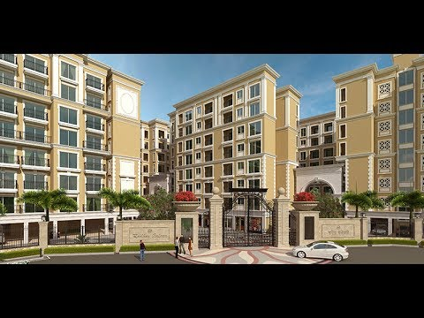

**About Project:-**

A renowned name in the Mumbai real estate market, Radhey Group is launching new upcoming luxurious development project in karjat,’Radhey Galaxy’. This is one of the beautiful and luxurious projects in Karjat with perfect blend of greenery and modern development with world class amenities. This is the family-friendly project comprises of 420 meticulously planned apartments offers 1BHK and 2BHK luxurious rooms in affordable prices which is suitable for people looking for both luxurious and comfort to live hassle-free lifestyle.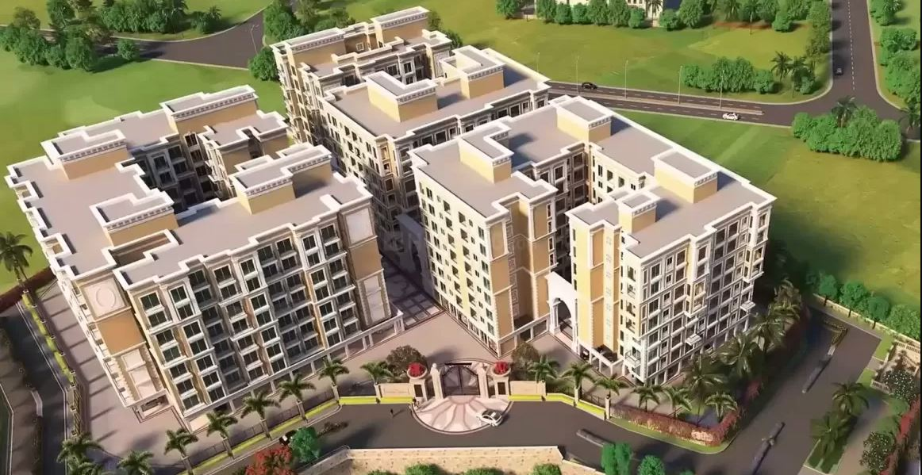

**Project Configuration Details:-**

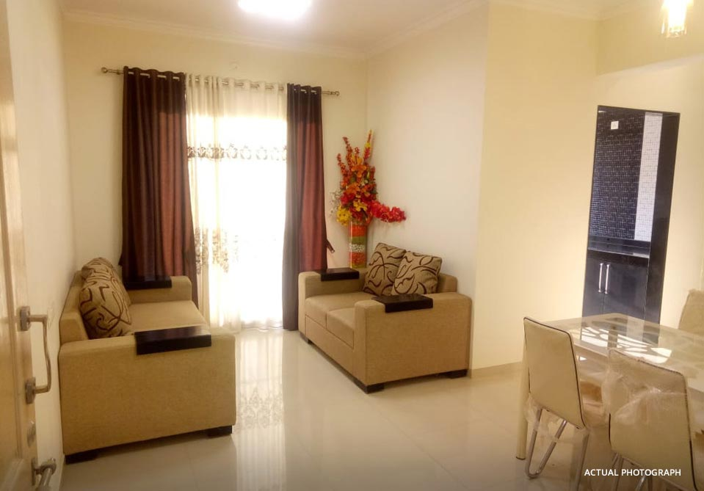

Radhey Galaxy is one of the best residential project of Radhey Group in Karjat which is newly and upcoming project in Karjat. This project is designed with modern features and amenities which gives comfort and hassle-free lifestyle in eco-friendly environment. The property offers 1BHK and 2BHK apartment consist of stylish floor with standardize kitchen, spacious balconies and many more little interior design makes the apartment look attractive. A review of Radhey Galaxy clearly indicates that this is one of the best Residential properties in Mumbai. This master plan of Radhey Galaxy comprise of 420 meticulously planned apartments which is designed according to customer requirements and needs. The price of apartment is affordable for people who looking for both luxury and comfort you've always dreamed of.

**Highlights:-**

* Family-Friendly apartment in an eco-friendly environment.
* Premium 2BHK and 1 BHK standardized 420 story’s apartment.
* High-quality fixture rooms and amenities.
* Transportation connectivity to all major regions.

**Project Amenities:-**

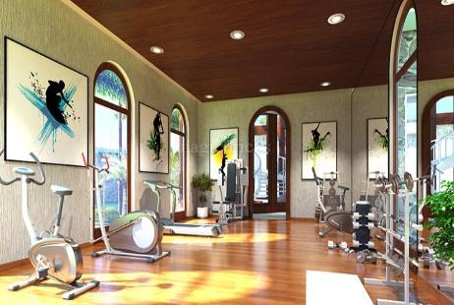

Radhey Galaxy Consist of Amenities like Landscaped Garden is available in wide area of compound within a complex can be used for relaxation and meditation purpose in a pure and greenery environmental place. Indoor and outdoor Games facilities are available to enjoy some time form busy scheduled life. Play Area with various activities that children’s can love to enjoy. For health and fitness relates, there is Swimming Pool, Clubhouse and Gymnasium are available which gives resort like feeling with in a complex. Overall structural and management facility of Radhey Galaxy indicates that it is one of the best residential properties.

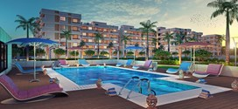

**Transportation facilities:-**

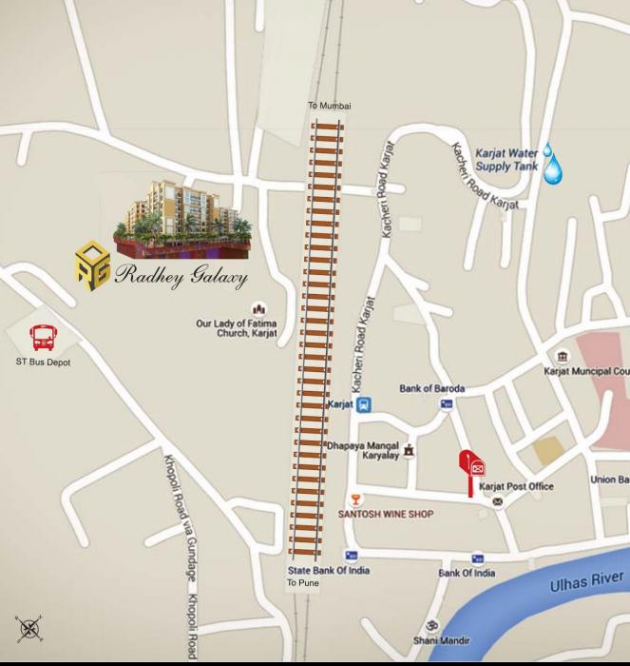

Radhey Galaxy is located in a region of pleasant climate in karjat which is well facilitated with transportation connectivity to all major cities and small region. Karjat is a region accessible via NH17, NH4 and NH3 highways. The extensive roadway networks connected to localities like Murbad, Kaiyanpur, Kasar Ghat, Khapoli, Khalapur, Neral, Badlapur, Ambernath, Pen, Panvel, etc.For moving from one region to other people can use their private four wheelers or two wheelers facilities. There is also a mixture of service in the region, comprising of MSRTC buses, 6-seater mindors, 3-seater auto rickshaws and 6-seater vans. The nearby station from Galaxy is karjat station which is just 3mins walkable distance away. This station is a junction where you can find an express train as well as local trains for moving towards Mumbai and Pune. There is also Airline facilities such as Chatrapati Shivaji International Airport and Navi Mumbai International Airport is nearest airport.

**Neighborhoods facilities:-**

Neighborhood facilities like various schools and institutes within the localities that a resident of area has no problems related to their children’s education. Some of the schools such as DAV Public school, St Joseph’s High School, India First Global School, New Horizon Public School, Biotech Research Institute, Dhirubhai Ambani School Lodhivali, etc.For healthcare related issues, residents doesn’t have to move to Mumbai for checkup, there are number of major health institution such as Raigad Hospital and Research Center, Madhavbaug Hospital,etc.There are also various Banks, ATM, Shopping centers and many more for residents without moving to metro Politian city, you can find all within the locality of Karjat.

**About Developers:-**

Radhey Group well-known developers in real estate market by constructing landmark properties in and around Mumbai, Thane, Panvel and navi Mumbai. Radhey Properties is helmed by Vinit Kedia, the son of J.P Kedia who was started the Radhey Group. The Life-long vision of Radhey Group is give back to society in the form of affordable housing for peoples from all socio-economic background to good. Today Radhey Properties has emerged as a leading player in the real estate market by focusing primarily on residential and commercial projects. The residential properties include villas, rowhouses, luxury apartments and economical homes while commercial properties comprise guesthouse and commercial buildings. These projects are overlooked by excellent qualified professionals, architect and consultant, who ensures that each project compiles with standard quality and delivered to customer on time.

1. **Landmark Casa Unico-**

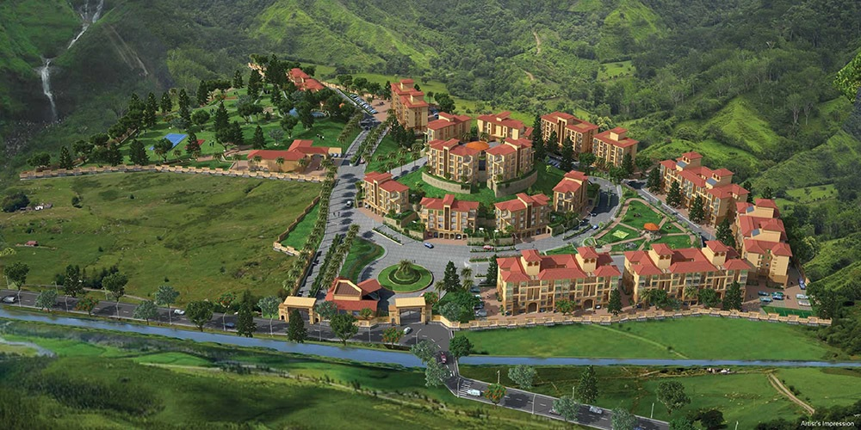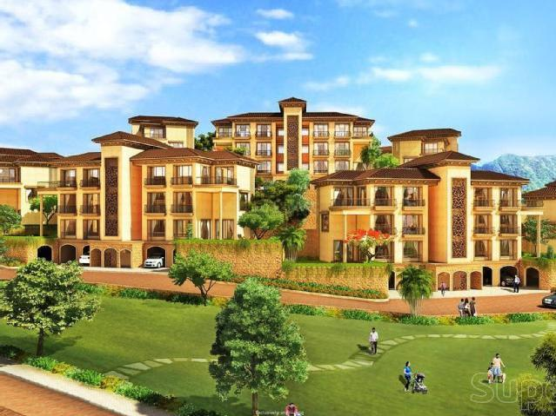

**About Project:-**

Landmark Casa Unico is a new upcoming project launched by Landmark developer who has a renowned name in real estate market. This project is located in Karjat which nearer to metropolitican cities like Mumbai and Pune. It is beautifully and meticulously designed with unbound convenience and best of amenities. It is perfect blend of greenery and modern development project comprises of 1BHK and 2BHK apartments in affordable price range which is suitable for peoples who looking for both luxury and comfort to live hassle-free lifestyle.

**Project Configuration Details:-**

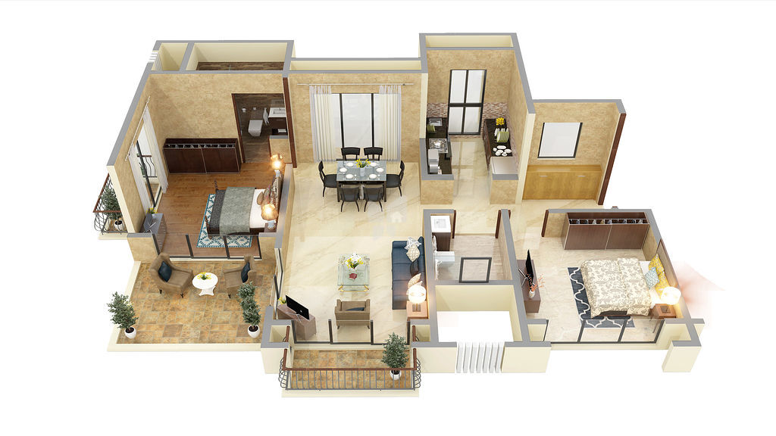Landmark Casa Unico is extremely eye-catching development project, designed with modern features and amenities for liviling comfortable life. This family-friendly project is suitable for small and large families, professionals, students in affordable price range. The property offers 1BHK and 2BHK apartment consist of spacious balconies, standardized kitchen, stylish flooring, attractive views, eco-friendly environment with pleasant climate. For 1BHK, carpet area ranges from 384-436 sq.ft and for 2BHK, carpet area ranges from 602-608 sq.ft. This wide area of apartments are offered in affordable price range i.e. 27L onwards. This master plan of landmark casa unico comprises of unique design that affirms a world-class lifestyle and prestigious accommodation in apartment. This is an ongoing project which is launched in Mar-2015 and possession of landmark casa unico project will be nearby Dec-2020.

**Highlights:-**

* Family-friendly apartment consisting of 1BHK and 2BHK apartment.
* Beautiful view scenery from balconies.
* Well-Equipped infrasture services and amenities.
* Transportation connectivity to various cities and small regions.

**Project Amenities:-**

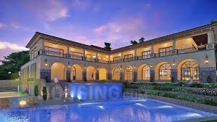Landmark Casa Unico comprises on many more amenities such as wide landscape garden, Indoor and outdoor games like Squash court and playing area.Infrasture consist of 24hrs water supply, Earthquake resistant, swimming pool, gymnasium, jogging tracks, meditation hall, yoga, Aerobic and Meditation room. For network and connectivity there is intercom service is available and gated community and security for safety and security. For Recreation there are club house and Banquet Hall and convenience library and 24hr Backup Electricity. For Entertainment and Eateries, there are Amphitheater and open lawns, Cafeteria and Barbecue.

**Transportation facilities:-**

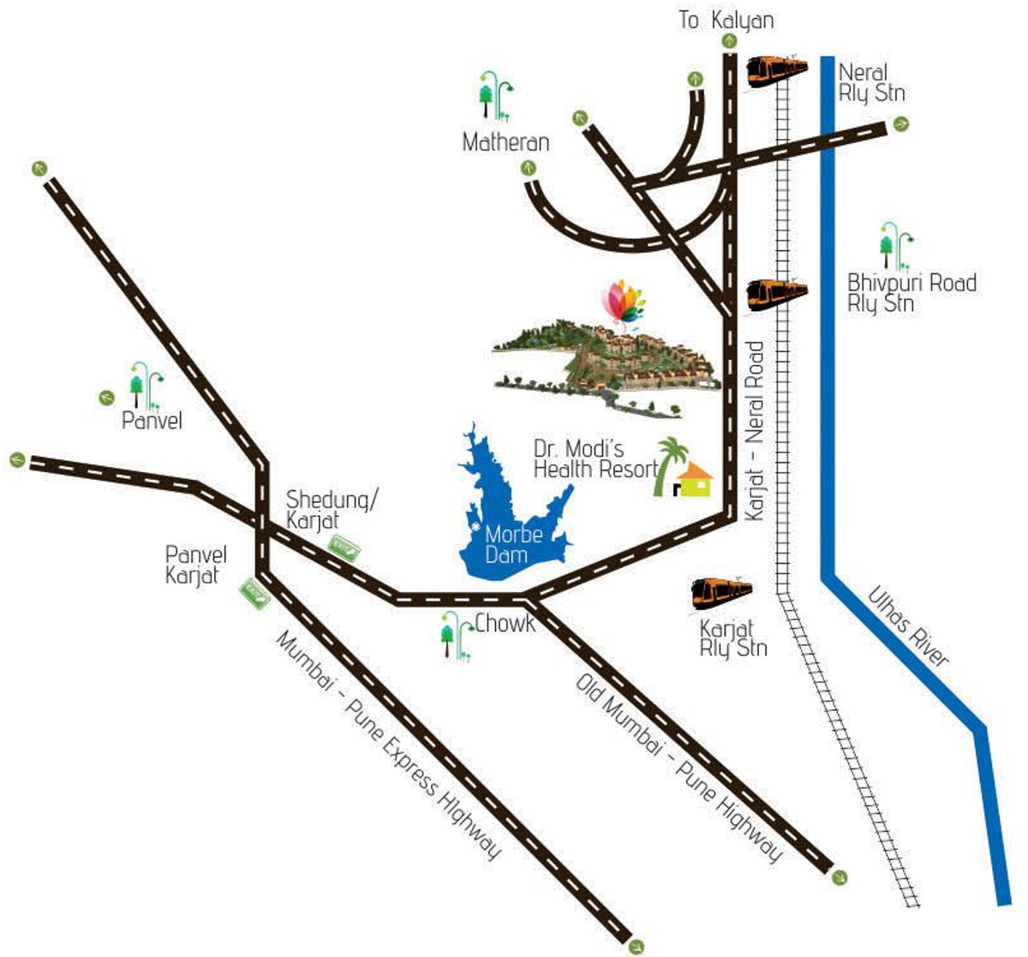

Landmark Casa Unico is located in a region of pleasant climate in karjat which is well facilitated with transportation connectivity to all major cities and small region. Karjat is a region accessible via NH17, NH4 and NH3 highways. The extensive roadway networks connected to localities like Murbad, Kaiyanpur, Kasar Ghat, Khapoli, Khalapur, Neral, Badlapur, Ambernath, Pen, Panvel, etc.For moving from one region to other people can use their private four wheelers or two wheelers facilities. There is also a mixture of service in the region, comprising of MSRTC buses, 6-seater mindors, 3-seater auto rickshaws and 6-seater vans. The nearby station from Galaxy is karjat station which is just few mins away. This station is a junction where you can find an express train as well as local trains for moving towards Mumbai and Pune. There is also Airline facilities such as Chatrapati Shivaji International Airport and Navi Mumbai International Airport is nearest airport.

**Neighborhoods facilities:-**

Neighborhood facilities like various schools and institutes within the localities that a resident of area has no problems related to their children’s education. Some of the schools such as DAV Public school, St Joseph’s High School, India First Global School, New Horizon Public School, Biotech Research Institute, Dhirubhai Ambani School Lodhivali, etc.For healthcare related issues, residents doesn’t have to move to Mumbai for checkup, there are number of major health institution such as Raigad Hospital and Research Center, Madhavbaug Hospital,etc.There are also various Banks, ATM, Shopping centers and many more for residents without moving to metro Politian city, you can find all within the locality of Karjat.

**About Developers:-**

In real estate market, Landmark developers has prime name for developing outstand luxurious apartment. The Foundation of Landmark developers were laid by Shri.G.M kakde as Chairman and Managing Director, who far sightedness combined with the diligence of Shri.Dinesh G Kakde as Joint Managing Director, has shaped the company’s reputation for apartments par excellence under their leadership. Landmark developers have built some of the best properties in Mumbai that includes luxury flats, premium apartments and commercial complexes that delight and satisfy its customer in every way.

1. **Tater Florence:-**

**About Project:-**

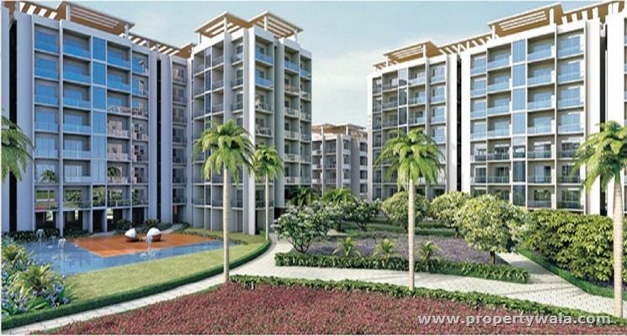

Tater Florence newly launched luxurious development project in karjat. This is one of the beautiful and outstanding luxurious properties with perfect blend of modern lifestyle with high quality class amenities. The project is constructed in pleasant and clam environment with attractive scenery view from apartment location. It is strategically located and provides direct connectivity to all nearby major points in and around this apartment. It is family-friendly project suitable for all small, large families, professionals, students. This ultimate reflection of the urban chic lifestyle apartment is available ready to move on June 2019.

**Project Configuration Details:-**

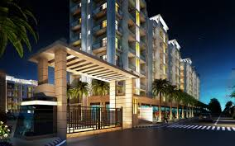

Tater Florence is extremely impressive in architecture, offers 1BHK and 2BHK apartments with 358 to 819 sq.ft carpet areas. This apartments are designed with modern features including vitrified flooring in all rooms, anti shid tiles are attached in terrace area, kitchen is designed with Granite platform with stainless sink and service platform, Designer bathrooms and toilets with branded sanitary ware, concealed plumbing with premium quality C.P.fittings,standardized and high quality doors and windows. These master plan apartments are offered in affordable price range i.e10.38L to 23.75L onwards. This apartment is suitable for all small, large families, professionals, students. This ultimate reflection of the urban chic lifestyle apartment is available ready to move on June 2019.

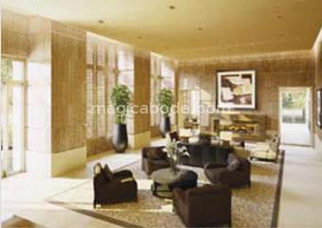

**Highlights:-**

* Family-friendly apartment in affordable price range in a pleasant environment.
* Premium 2BHK and 1BHK standardized apartments with modern amenities.
* Easy accessible to attractive and beautiful weekend places.
* 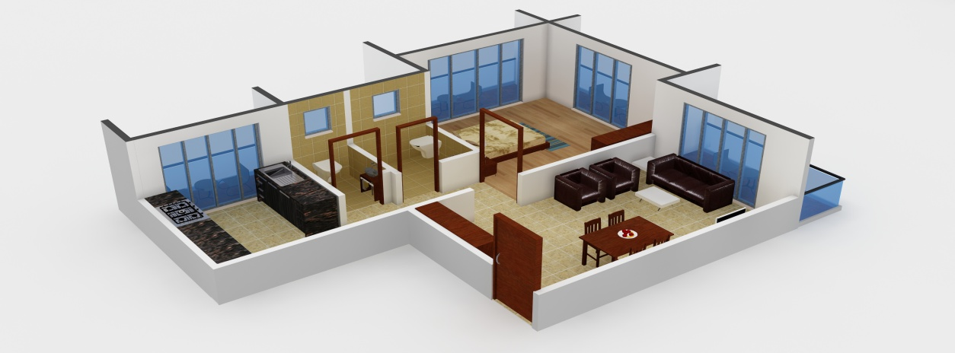Well-transportation connectivity to all small and major regions from locality

**Project Amenities:-**

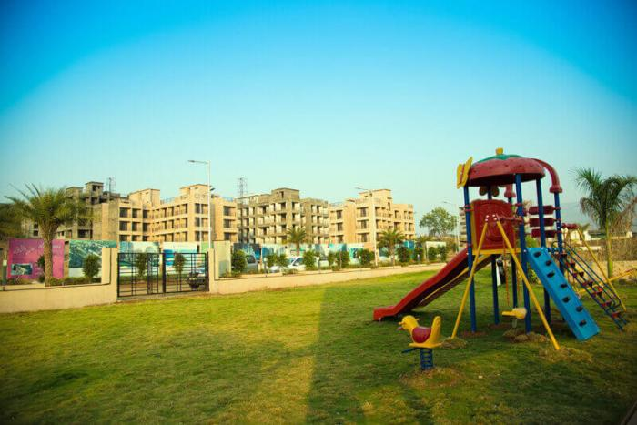

This impressive and modern feature apartment consisting of amenities such Community Hall, Club House, Party Area, 24hr Backup Electricity, Swimming Pool,Gymnasium,Yoga,Aerobics and Meditation Room, Play Area,library,Table Tennis, Amphitheater and open lawns and many more amenities that makes life comfort and easy.

**Transportation facilities:-**

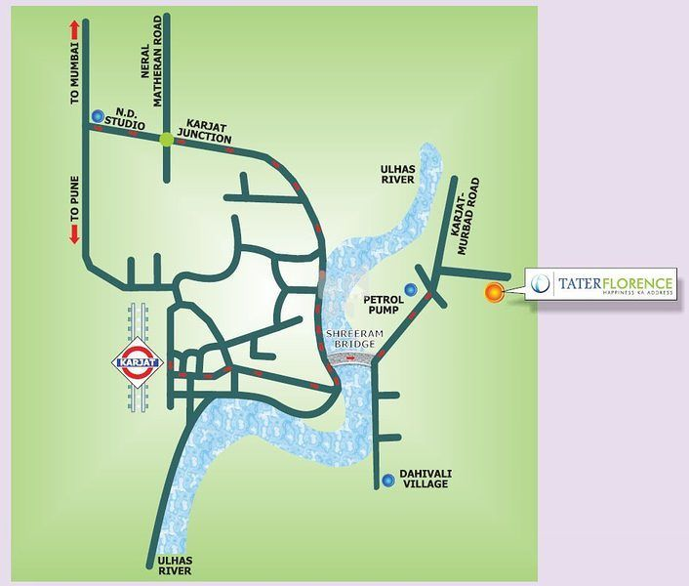

Tater Florence is located in a region of pleasant climate in karjat which is well facilitated with transportation connectivity to all major cities and small region. Karjat is a region accessible via NH17, NH4 and NH3 highways. The extensive roadway networks connected to localities like Murbad, Kaiyanpur, Kasar Ghat, Khapoli, Khalapur, Neral, Badlapur, Ambernath, Pen, Panvel, etc.For moving from one region to other people can use their private four wheelers or two wheelers facilities. There is also a mixture of service in the region, comprising of MSRTC buses, 6-seater mindors, 3-seater auto rickshaws and 6-seater vans. The nearby station from Galaxy is karjat station which is just few mins distance away. This station is a junction where you can find an express train as well as local trains for moving towards Mumbai and Pune. There is also Airline facilities such as Chatrapati Shivaji International Airport and Navi Mumbai International Airport is nearest airport.

**Neighborhoods facilities:-**

Neighborhood facilities like various schools and institutes within the localities that a resident of area has no problems related to their children’s education. Some of the schools such as DAV Public school, St Joseph’s High School, India First Global School, New Horizon Public School, Biotech Research Institute, Dhirubhai Ambani School Lodhivali, etc.For healthcare related issues, residents doesn’t have to move to Mumbai for checkup, there are number of major health institution such as Raigad Hospital and Research Center, Madhavbaug Hospital,etc.There are also various Banks, ATM, Shopping centers and many more for residents without moving to metro Politian city, you can find all within the locality of Karjat.

**About Developer:-**

Tater Florence is a leading real estate company, famous for developing impressive projects across Navi Mumbai. The main focus of the company is to develop standardized homes with high quality materials, designed by experienced professional architectures and always tries to deliver on time. By providing world-class product and services to customer, desire to earn trust and confidence.

1. **Signature Desire:-**

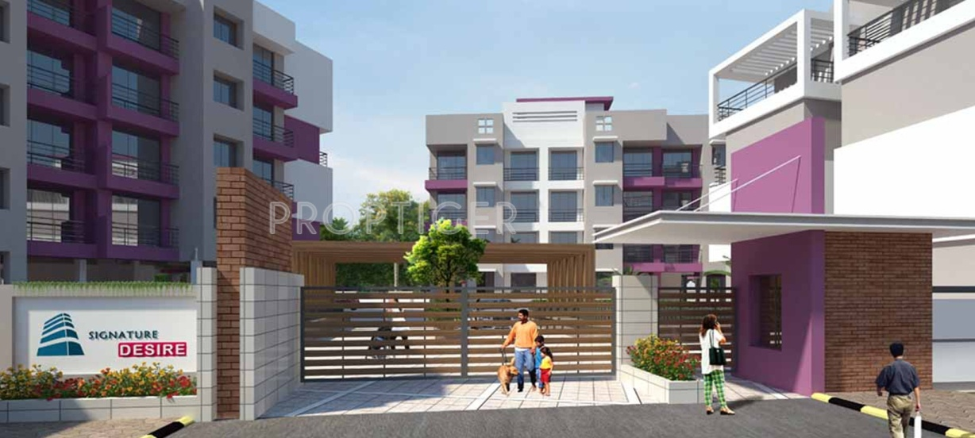

**About Project:-**

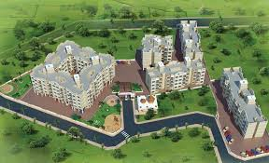

The Signature Desire is newly ongoing luxurious development project in Karjat. This project was developed by Signature Group, who is leading group in real estate market in Mumbai and Navi Mumbai. This is extremely attractive project with perfect blend of greenery and modern development with world-class amenities. It is suitable for all type of peoples looking for both luxury and comfort such as small and large families, professions, students.

**Project Configuration Details:-**

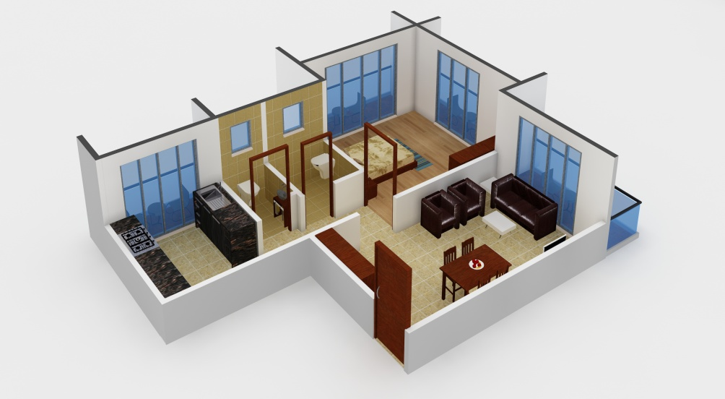

Signature Desire is an unmatchable Residential property located in Karjat, offers a desirable houses to their customers in affordable price range. They offer an apartment of 1BHK, 1RK and 2BHK apartment with carpet area of 224-675 sq.ft. This apartments are designed with modern features including 2*2 vitrified flooring in entire flats, kitchen decorated with granite platform and stainless steel sink, ceramic tiles, above kitchen platform up to Beam height, Elegant designer wall tiles up to door height, doors are decorated with laminated finishing to main and internal wooden doors,aluminium sliding windows in all rooms and kitchen, modular switches and wiring all over the rooms, walls painted with good quality, water tank facility for adequate storage capacity, special waterproofing treatment terrace, Lift facilties.The overall review of the Signature desire indicates that it is one of the best residential apartment which looks impressive and attractive.

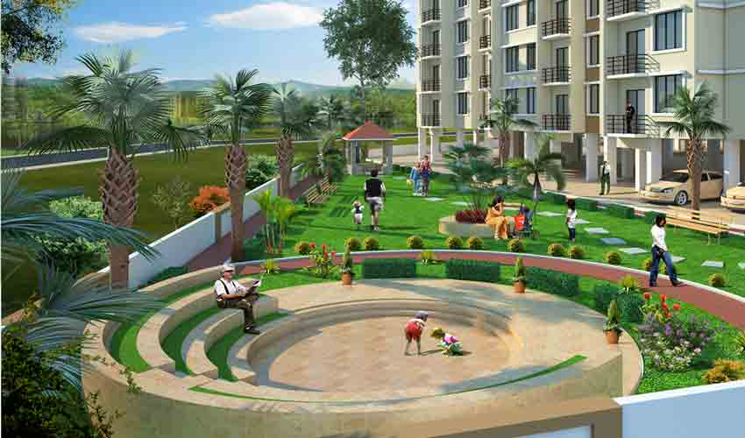

**Highlights:-**

* Apartment comprises of 1BHK and 2BHK apartments
* Family-Friendly apartment in an eco-friendly environment.
* High-quality fixture rooms and amenities.
* Well transport connectivity to all major region and cities.

**Project Amenities:-**

Signature Desire is one of the impressive residential apartment with well-equipped amenities such as LandscapeGardern,EarthquakeResidentialinfrastructure,CCTVCameras,GatedCommunity,Security,Community Hall, Club House, Party Area, Senior Citizen Park,Gymnasium,Jogging track, for outdoor games there is playing area,lift,Rani water Harvesting,24Hr Backup Electricity, Health facilities, Drainage and sewage treatment, waste management system,24Hr water supply, fire Alarmed.

**Transportation facilities:-**

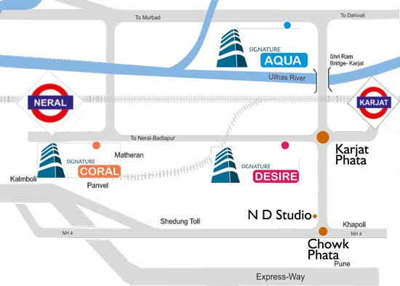

Signature Desire is located in a region of pleasant climate in karjat which is well facilitated with transportation connectivity to all major cities and small region. Karjat is a region accessible via NH17, NH4 and NH3 highways. The extensive roadway networks connected to localities like Murbad, Kaiyanpur, Kasar Ghat, Khapoli, Khalapur, Neral, Badlapur, Ambernath, Pen, Panvel, etc.For moving from one region to other people can use their private four wheelers or two wheelers facilities. There is also a mixture of service in the region, comprising of MSRTC buses, 6-seater mindors, 3-seater auto rickshaws and 6-seater vans. The nearby station from Signature Desire is karjat station which is nearby walkable distance away. This station is a junction where you can find an express train as well as local trains for moving towards Mumbai and Pune. There is also Airline facilities such as Chatrapati Shivaji International Airport and Navi Mumbai International Airport is nearest airport.

**Neighborhoods facilities:-**

Neighborhood facilities like various schools and institutes within the localities that a resident of area has no problems related to their children’s education. Some of the schools such as DAV Public school, St Joseph’s High School, India First Global School, New Horizon Public School, Biotech Research Institute, Dhirubhai Ambani School Lodhivali, etc.For healthcare related issues, residents doesn’t have to move to Mumbai for checkup, there are number of major health institution such as Raigad Hospital and Research Center, Madhavbaug Hospital,etc.There are also various Banks, ATM, Shopping centers and many more for residents without moving to metro Politian city, you can find all within the locality of Karjat.

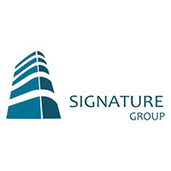**About Developer:-**

Signature Group is well-known developers in real estate market for developing attractive projects in Mumbai and Navi Mumbai. The young entrepreneurs of signature group was established the group with objective of developing good quality of projects. These projects are overlooked by excellent qualified professionals, architect and consultant, who ensures that each project compiles with standard quality and delivered to customer on time.

1. **Shreeji Aura:-**

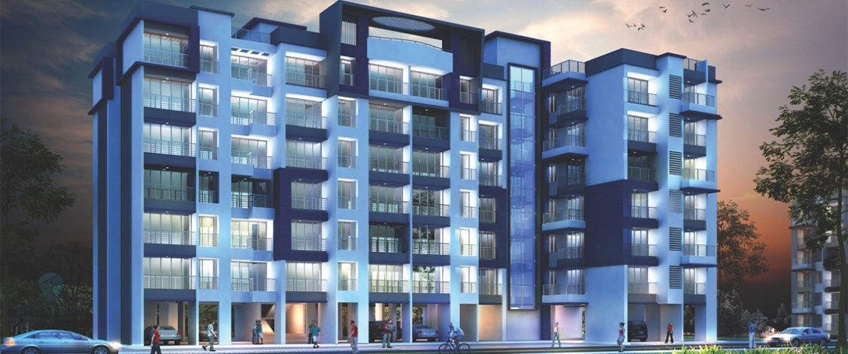

**About Project:-**

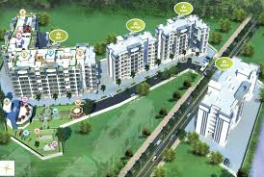

Shreeji Aura is renowned name in real estate industry for developing outstanding projects in and out of Mumbai. Shreeji Aura developers always focuses on developing standardized homes with motive of high quality materials, experienced professional architectures, deliver on time and ensures value of money. Dreams of people to buy their own house, they help them to make their dreams come true. Because they desire to earn peoples trust and confidence by providing world-class product and services to their customers.

**Project Configuration Details:-**

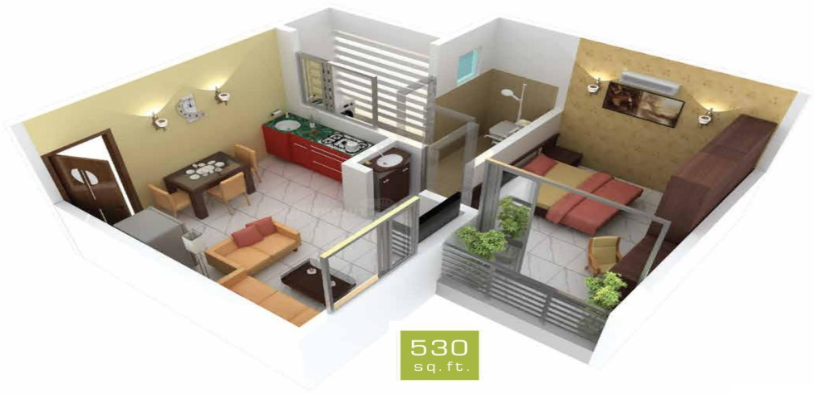

Shreeji Aura is one of the best residential projects, located in prime location of karjat. It provides lavish lifestyle and comfort to their residents with great amenities, friendly and healthily surrounding environments. Shreeji Aura offers 1BHK apartments consist of carpet area of around 280 to 348 sq.ft, in affordable price range starting from 10.18L to12.65 L onwards. This project is spread over and 4.00 acres with 7 floors. The master plan of Shreeji Aura is designed in such a way that these apartments comprise of wide space with proper ventilation at every corner of the house. The interiors are beautifully designed with stylish flooring, granite counter slab in kitchen, modern bathrooms, and wide windows with beautiful sunrays fall apart.

**Highlights:-**

* Family-friendly apartment in affordable price range in a pleasant environment.
* Premium 1BHK standardized apartments with modern amenities.
* Easy accessible to attractive and beautiful weekend places.
* Well-transportation connectivity to all small and major regions from locality.

**Project Amenities:-**

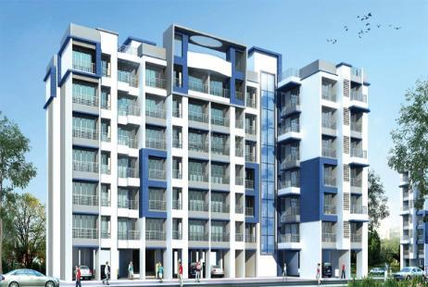

Shreeji Aura review indicates that it is one of the impressive residential apartment with well-equipped amenities include Landscape Garden with eco-friendly climate, Lift facilities, Indoor and outdoor game facilities such as table tennis,CCTV Cameras for safety and security. Fitness related amenities such as Swimming Pool, Gymnasium, Jogging track, meditation halls are available and for children’s there is play Area, cricket Court, Basket Ball court. The Wi-Fi and Intercom network communication facility, 24hr Backup Electricity, Club House, Temple, Party Area, and Senior Citizen Park. For Entertainment purpose Amphitheater and Open Lawns, Toddlers Pooled.

**Transportation facilities:-**

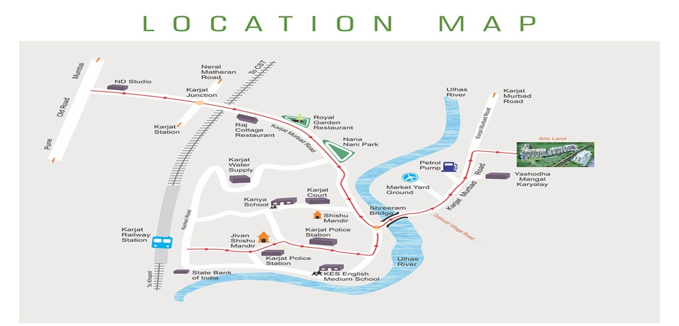

Shreeji Aura is located in a region of pleasant climate in karjat which is well facilitated with transportation connectivity to all major cities and small region. Karjat is a region accessible via NH17, NH4 and NH3 highways. The extensive roadway networks connected to localities like Murbad, Kaiyanpur, Kasar Ghat, Khapoli, Khalapur, Neral, Badlapur, Ambernath, Pen, Panvel, etc.For moving from one region to other people can use their private four wheelers or two wheelers facilities. There is also a mixture of service in the region, comprising of MSRTC buses, 6-seater mindors, 3-seater auto rickshaws and 6-seater vans. The nearby station from Shreeji Aura is karjat station which is nearby walk able distance away. This station is a junction where you can find an express train as well as local trains for moving towards Mumbai and Pune. There is also Airline facilities such as Chatrapati Shivaji International Airport and Navi Mumbai International Airport is nearest airport.

**Neighborhoods facilities:-**

Neighborhood facilities like various schools and institutes within the localities that a resident of area has no problems related to their children’s education. Some of the schools such as DAV Public school, St Joseph’s High School, India First Global School, New Horizon Public School, Biotech Research Institute, Dhirubhai Ambani School Lodhivali, etc.For healthcare related issues, residents doesn’t have to move to Mumbai for checkup, there are number of major health institution such as Raigad Hospital and Research Center, Madhavbaug Hospital,etc.There are also various Banks, ATM, Shopping centers and many more for residents without moving to metro Politian city, you can find all within the locality of Karjat.

**About Developer:-**

Shreeji Aura developers always focuses on developing standardized homes with high quality materials, experienced professional architecure's,tries to deliver on time and ensures value of money. Dreams of people to buy their own house, we help them to make their dreams come true. Because we desire to earn peoples trust and confidence by providing world-class product and services to our customers.

1. **Eco Phase II Project:-**

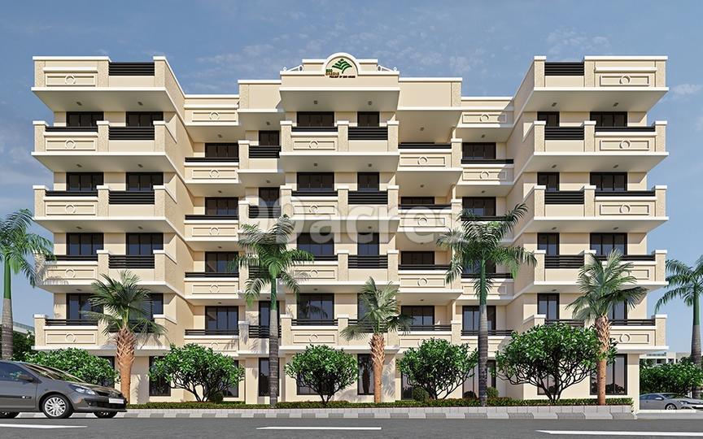

**About:-**

Eco Green phase II is an attractive and impressive project in karjat with serving as a desirable model in greenery. The featured such as Solar Street lights, solar water heater, Eco friendly wetland sewerage treatment system, herbal garden and over two hundreds trees. It is centrally located project with perfectly encapsulated modern living and offers luxury apartments of 1-2 bedroom rooms, designed with complementary architectural interiors with high quality finishing and meticulous attentions at every residential home.

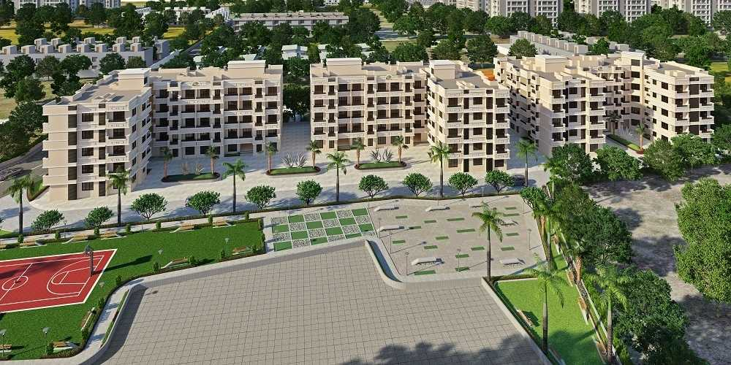

**Project Configuration:-**

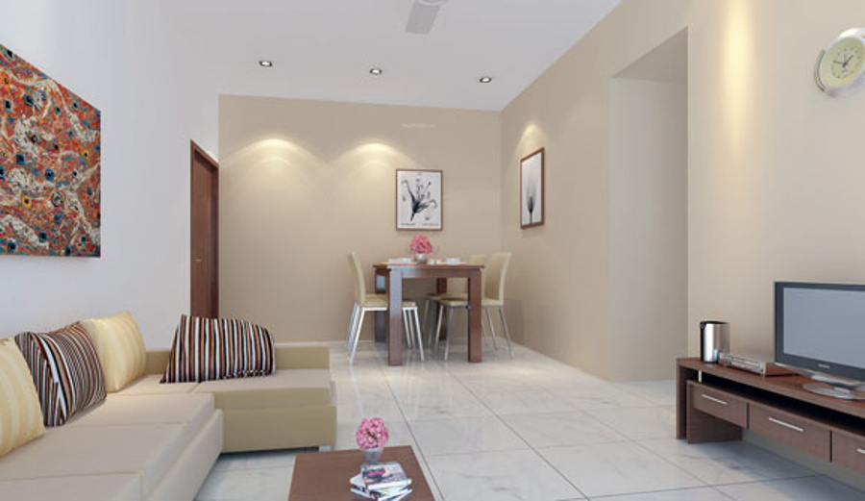

The luxurious residential apartment of Eco greens phase II is an iconic and eye-catching project developed in the prime location of Mumbai. The project comprises of premium 1BHK and 2BHK residential apartment with configuration starting from 338-510 sq.ft.These apartments are offered in an affordable price range such as 14.58L-22L onwards. Each apartment are finely crafted and committed to provide houses with unmatched quality. The apartments are spacious, well ventilated and vastu compliant this project is constructed in a deliberated location at karjat were offers seamless connectivity to localities by extensive roadway networks and highways. It is suitable for every type of peoples including small and large families, professionals, students, etc.Constructed very carefully with quality and excellence in mind, co-friendly construction practices and products and timely delivery.

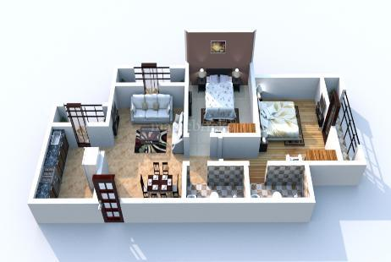

**Highlights:-**

* Premium of 1BHK and 2BHK apartment
* Perfect living in peace, purity and positivity.
* Constructed with high quality amenities and features.
* Well transportation connectivity across the region.

**Amenities:-**

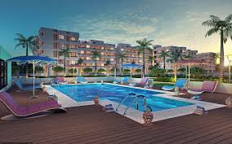

Eco green Phase II is an impressive and urban style designed apartment consist of amenities such as Swimming Pool and Gymnasium, Jogging track for taking care of fitness of residents, Outdoor games such as play area, Tennis Court, Cricket Court, Basket Ball Court.etc.There are Rain Water Harvesting, Solar lighting, convenience lift, 24hr backup electricity, club house for recreation, Drainage and sewage treatment for safety and security, Multipurpose game court for indoor games.

**Transportation facilities:-**

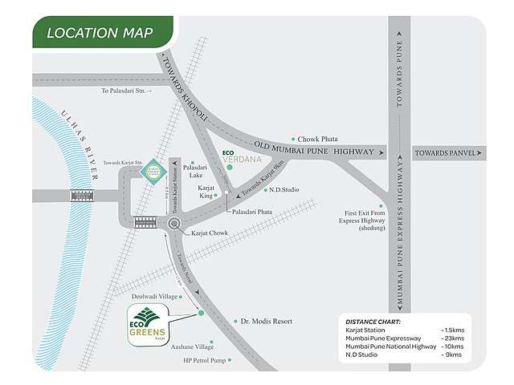

Eco phase II is located in a region of pleasant climate in karjat which is well facilitated with transportation connectivity to all major cities and small region. Karjat is a region accessible via NH17, NH4 and NH3 highways. The extensive roadway networks connected to localities like Murbad, Kaiyanpur, Kasar Ghat, Khapoli, Khalapur, Neral, Badlapur, Ambernath, Pen, Panvel, etc.For moving from one region to other people can use their private four wheelers or two wheelers facilities. There is also a mixture of service in the region, comprising of MSRTC buses, 6-seater mindors, 3-seater auto rickshaws and 6-seater vans. The nearby station from apartment is karjat station which is just few mintues away from residential apartment. This station is a junction where you can find an express train as well as local trains for moving towards Mumbai and Pune. There is also Airline facilities such as Chatrapati Shivaji International Airport and Navi Mumbai International Airport is nearest airport.

**Neighborhoods facilities:-**

Neighborhood facilities like various schools and institutes within the localities that a resident of area has no problems related to their children’s education. Some of the schools such as DAV Public school, St Joseph’s High School, India First Global School, New Horizon Public School, Biotech Research Institute, Dhirubhai Ambani School Lodhivali, etc.For healthcare related issues, residents doesn’t have to move to Mumbai for checkup, there are number of major health institution such as Raigad Hospital and Research Center, Madhavbaug Hospital,etc.There are also various Banks, ATM, Shopping centers and many more for residents without moving to metro Politian city, you can find all within the locality of Karjat.

**About Developers:-**

Eco Green Phase II is developed by renowned architectural engineer of Ecohomes Constructions pvt.ltd.They form a large group who involved in producing various residential and commercial projects with beautiful crafted interiors as well as exteriors. Striving for excellence and perfection, Ecohomes takes pride in having completed a huge number of projects across Mumbai, Navi Mumbai and many more places. The developments of projects are constructed very carefully with quality and excellence in mind and timely delivery to the customers.

1. **SagarSargam:-**

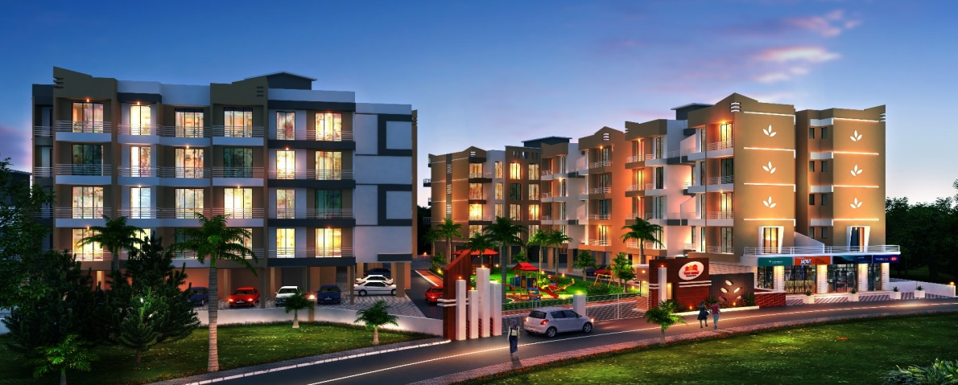

**About:-**

Shree Tulsi Developers, newly launched a residential project, named as Sagar Sargam Residency at karjat in Maharashtra. It is one of the impressive residential projects with well connected to various modes of transportation and services within localities. The project offers eye-catching designed with complementary architectural interiors with high quality finishing and meticulous attention at every residential home. These enriching and refreshing apartments enhance the standard living without compromise in luxury.

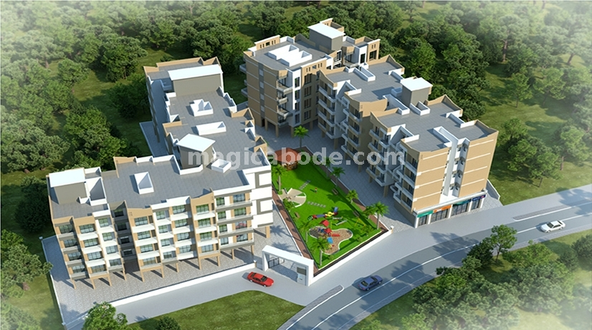

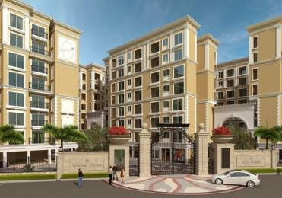**Project Configuration:-**

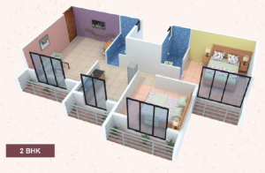For experience urban lifestyle living, SagarSargam residential apartment is an abode of magnificent apartment in karjat with all modern features required for contemporary lifestyle with refreshing green views. The project consist of 1BHK and 2BHK apartments with configuration of 215-370 sq.ft in flexible and affordable price that people from all class can improve their standard of living without compromising in comfort. The floor planning is designed in such away, that it enables the best utilization of the space from stylish flooring to spacious balconies, standard kitchen size and high-quality fixtures, every little detail gives here an attractive look. The review of apartment indicates that it is one of the best residential projects in Mumbai. This project is constructed in a deliberated location where beautiful view and location scenery can be viewed from the residents. It also offers seamless connectivity to all major localities by extensive roadway networks and highways.

**Highlights:-**

* Premium of 1BHK and 2BHK apartment
* Standardized living with high quality amenities.
* Located in prime location, in affordable price range.
* Well transportation connectivity across the region.

**Amenities:-**

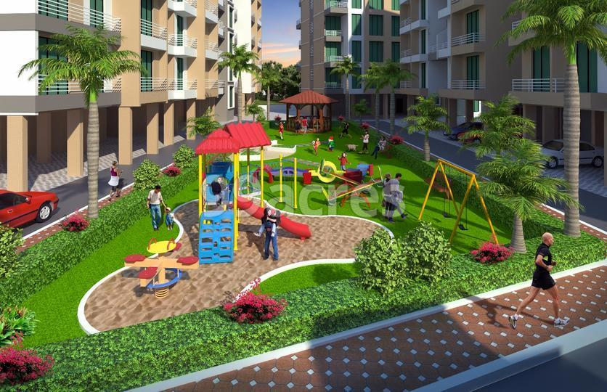 Sagar Sargam is a beautifully designed project without compromising in comfort and luxury for residents with all necessary amenities and features to live standardized life in an affordable price range. The amenities include Jogging Track for being healthily in eco-friendly nature, wide area landscape garden for relaxation and meditation, lift for convenience, Senior Citizen area, for safety and security there is CCTV camera, Children’s play area and many more amenities that can be impress you while reviewing these excited apartment from live location.

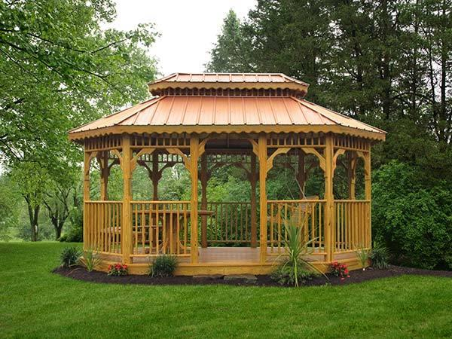

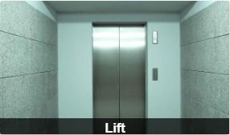

**Transportation:-**

SagarSargam is located in a region of pleasant climate in karjat which is well facilitated with transportation connectivity to all major cities and small region. Karjat is a region accessible via NH17, NH4 and NH3 highways. The extensive roadway networks connected to localities like Murbad, Kaiyanpur, Kasar Ghat, Khapoli, Khalapur, Neral, Badlapur, Ambernath, Pen, Panvel, etc.For moving from one region to other people can use their private four wheelers or two wheelers facilities. There is also a mixture of service in the region, comprising of MSRTC buses, 6-seater mindors, 3-seater auto rickshaws and 6-seater vans. The nearby station from apartment is karjat station which is just 7mins away from residential apartment. This station is a junction where you can find an express train as well as local trains for moving towards Mumbai and Pune. There is also Airline facilities such as Chatrapati Shivaji International Airport and Navi Mumbai International Airport is nearest airport.

**Neighborhoods facilities:-**

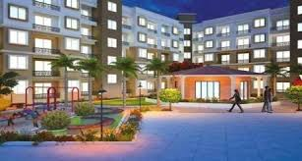

Neighborhood facilities like various schools and institutes within the localities that a resident of area has no problems related to their children’s education. Some of the schools such as DAV Public school, St Joseph’s High School, India First Global School, New Horizon Public School, Biotech Research Institute, Dhirubhai Ambani School Lodhivali, etc.For healthcare related issues, residents doesn’t have to move to Mumbai for checkup, there are number of major health institution such as Raigad Hospital and Research Center, Madhavbaug Hospital,etc.There are also various Banks, ATM, Shopping centers and many more for residents without moving to metro Politian city, you can find all within the locality of Karjat.

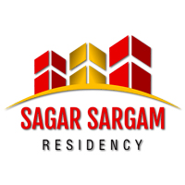**About Developers:-**

This SagarSargam residential apartment is developed by Shree Tulsi Developers, who are well-known for their work in real estate market for developing elegant projects in across the region in Maharashtra. They always focuses on providing dream home with quality ensures complementary architectural design and timely delivery to customers. The main motive is to improve the standardized living without comprising comfort and live a luxury life.

1. **Mount Ville :-**

**About Project:-**

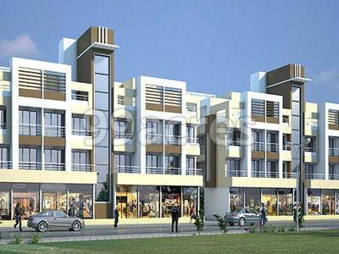

Mount Ville is one of the elegant residential projects of Samvid Group in Karjat. Elevate the contemporary lifestyle in a sprawling luxury enclave of magnificent apartments of Mount Ville. It is impressive residential project designed with complementary architecture, comprises of 1BHK and 2BHK apartment. The Mount Ville is located in a prime location that provides easy accessible to various regions and availability of transportation service.

**Project Configuration Details:-**

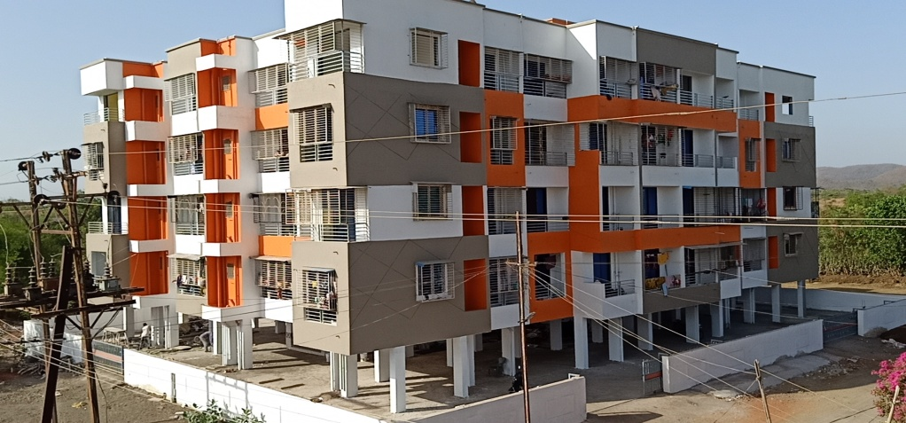

Mount Ville is an eye-catching project development of Samvid Group in karjat, meticulously designed with unbound convenience and best of aminities.Mount ville offers 1BHK and 2BHK luxurious apartments. with carpet area of 228-850 sq.ft The floor planning enables the best utilization of the space from stylish flooring to spacious balconies, standard kitchen size and high-quality fixtures, every little details gives here an attractive look. The review of apartment indicates that it is one of the best residential projects in Mumbai. This project is constructed in a deliberated location where beautiful view and location scenery can be viewed from the residents. It also offers seamless connectivity to all major localities by extensive roadway networks and highways.

**Highlights:-**

* Premium of 1BHK and 2BHK apartment.
* Standardized living with high quality amenities.
* Located in prime location, in affordable price range.
* Well transportation connectivity across the region.

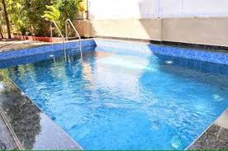**Project Amenities:-**

Mount Ville is an impressive residential apartment with well-equipped amenities such as CCTV Camera, Gated community for security and safety purpose, Earthquake Resistant infrastructure, Convenience of Lift,24Hr Backup Electricity,Ac Lobby, Drainage and sewage treatment for waste management, Open parking, Water tank facilities for storage, Outdoor playing area for childerns,etc.



**Transportation facilities:-**

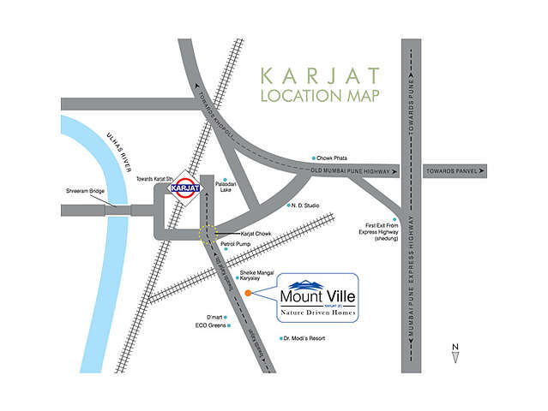

Mount Ville is located in a region of pleasant climate in karjat which is well facilitated with transportation connectivity to all major cities and small region. Karjat is a region accessible via NH17, NH4 and NH3 highways. The extensive roadway networks connected to localities like Murbad, Kaiyanpur, Kasar Ghat, Khapoli, Khalapur, Neral, Badlapur, Ambernath, Pen, Panvel, etc.For moving from one region to other people can use their private four wheelers or two wheelers facilities. There is also a mixture of service in the region, comprising of MSRTC buses, 6-seater mindors, 3-seater auto rickshaws and 6-seater vans. The nearby station from Mount Ville is karjat station which is just few minutes distance away. This station is a junction where you can find an express train as well as local trains for moving towards Mumbai and Pune. There is also Airline facilities such as Chatrapati Shivaji International Airport and Navi Mumbai International Airport is nearest airport.

**Neighborhoods facilities:-**

Neighborhood facilities like various schools and institutes within the localities that a resident of area has no problems related to their children’s education. Some of the schools such as DAV Public school, St Joseph’s High School, India First Global School, New Horizon Public School, Biotech Research Institute, Dhirubhai Ambani School Lodhivali, etc.For healthcare related issues, residents doesn’t have to move to Mumbai for checkup, there are number of major health institution such as Raigad Hospital and Research Center, Madhavbaug Hospital,etc.There are also various Banks, ATM, Shopping centers and many more for residents without moving to metro Politian city, you can find all within the locality of Karjat.

**About Developer:-**

Samvid Group is famous for developing attractive projects in and around karjat. They helps the people to living in their dream home in affordable price, convenient for all types of people from middle class to high class people. They focus on fulfilling the dreams of people by developing luxurious apartment in all amenities without compromising in comfort. They desire to earn peoples trust and confidence by their services, quality of building, timely delivery and ensure value for money.

1. **Unimont Aurum:-**

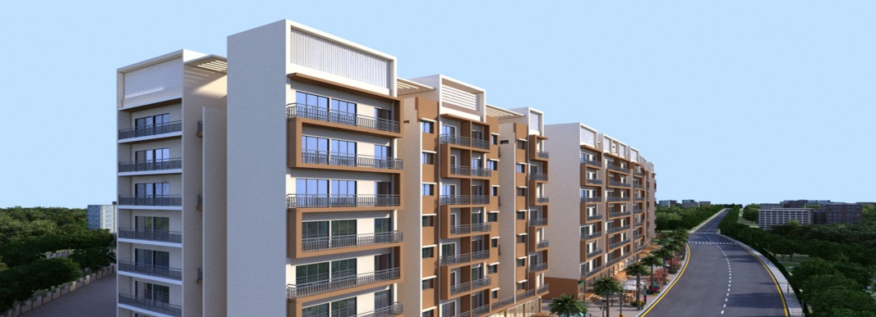

**About Project:-**

Unimont Aurum is one of new and upcoming project in karjat which is developed Unimont Group. Unimont Aurum is recently launched in Aug 2019, spread across 2.08 Acres area and consisting of project size of 7 buildings residential apartment. It is township project with attractive elevation, include apartment with studio, deluxe studio, 1 & 2 BHK spread across 6 towers. From Unimont Aurum, you can find well connect and easy access to all major regions via local transport service, railway and airlines.

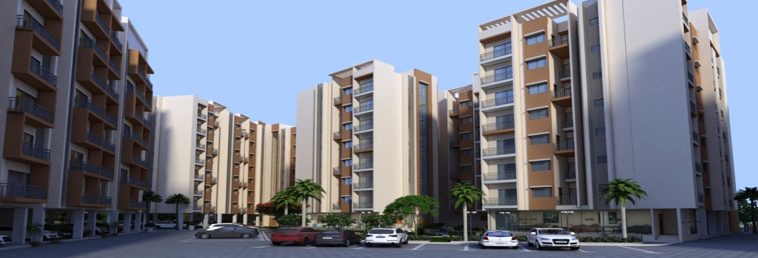

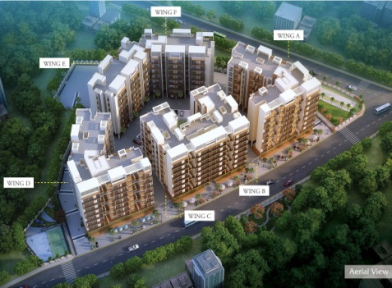**Project Configuration Details:-**

Unimont Aurum is an attractive elevated township project, brings luxurious and lavish lifestyle to residents. This project consists of G+ 7 residential apartments with studio, 1BHK, 2BHK and 1RK rooms. This apartments are available in affordable price range with configuration starts from 15.62 sq.mt to 33.80 sq.mt.The floor planning enables the best utilization of the space from stylish flooring to spacious balconies, standard kitchen size and high-quality fixtures, every little details gives here an attractive look. The amenities and specification of each room consist of kitchen and bathrooms. The kitchens are designed with granite platform with ss sink, designer glazed tiles up to beam level in kitchen above platform. Bathrooms consist of designer tiles up to door height. The review of apartment indicates that it is one of the best residential projects in Mumbai. This project is constructed in a deliberated location where beautiful view and location scenery can be viewed from the residents. It also offers seamless connectivity to all major localities by extensive roadway networks and highways.

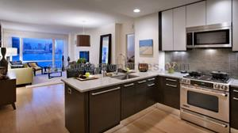

**Highlights:-**

* Premium of 1BHK and 2BHK apartment
* Perfect living in peace, purity and positivity.
* Constructed with high quality amenities and features.
* Well transportation connectivity across the region.

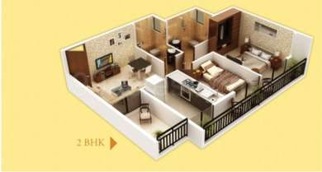

**Project Amenities:-**

Unimont Aurum is a beautifully designed project without compromising in comfort and luxury for residentials; consist of all necessary amenities and features to live standardized life in an affordable price range. The amenities include Jogging Track, Swimming Pool, Gymnasium for being healthily in eco-friendly nature, wide area landscape garden for relaxation and meditation, lift for conveience,Childerns play area, skating and Indoor games facilities and many more amenities that can be impress you while reviewing these excited apartment from live location.

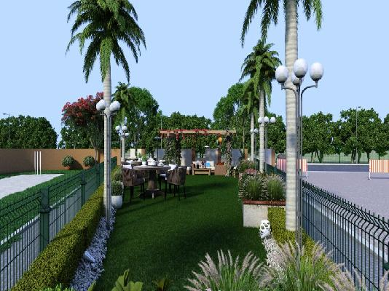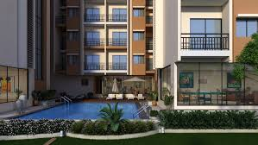

**Transportation facilities:-**

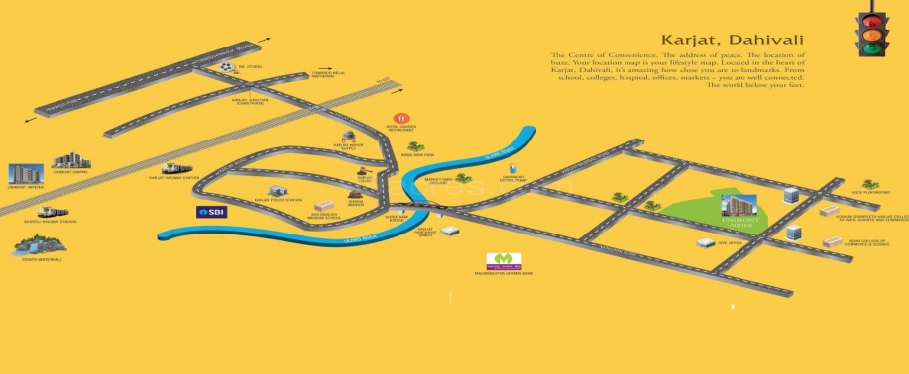

Unimont Aurum is located in a region of pleasant climate in karjat which is well facilitated with transportation connectivity to all major cities and small region. Karjat is a region accessible via NH17, NH4 and NH3 highways. The extensive roadway networks connected to localities like Murbad, Kaiyanpur, Kasar Ghat, Khapoli, Khalapur, Neral, Badlapur, Ambernath, Pen, Panvel, etc.For moving from one region to other people can use their private four wheelers or two wheelers facilities. There is also a mixture of service in the region, comprising of MSRTC buses, 6-seater mindors, 3-seater auto rickshaws and 6-seater vans. The nearby station from Galaxy is karjat station which is just 1.5km distance away. This station is a junction where you can find an express train as well as local trains for moving towards Mumbai and Pune. There is also Airline facilities such as Chatrapati Shivaji International Airport and Navi Mumbai International Airport is nearest airport.

**Neighborhoods facilities:-**

Neighborhood facilities like various schools and institutes within the localities that a resident of area has no problems related to their children’s education. Some of the schools such as DAV Public school, St Joseph’s High School, India First Global School, New Horizon Public School, Biotech Research Institute, Dhirubhai Ambani School Lodhivali, etc.For healthcare related issues, residents doesn’t have to move to Mumbai for checkup, there are number of major health institution such as Raigad Hospital and Research Center, Madhavbaug Hospital,etc.There are also various Banks, ATM, Shopping centers and many more for residents without moving to metro Politian city, you can find all within the locality of Karjat.

**About Developer:-**

Unimont Group are well-known named real estate market, it was established in year 2010.They always focuses on developing standardized homes with high quality materials, experienced professional architecure's,tries to deliver on time and ensures value of money. Dreams of people to buy their own house, we help them to make their dreams come true. Because we desire to earn peoples trust and confidence by providing world-class product and services to our customers.